SQL ASSIGNMENT -7

ROLL NO-84016

Q1Write a query that counts all orders for October 3.
Ans.
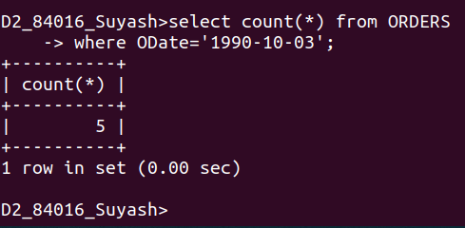

Q2.Writ a query that counts the number of different non-NULL city values in the customers table.
Ans.
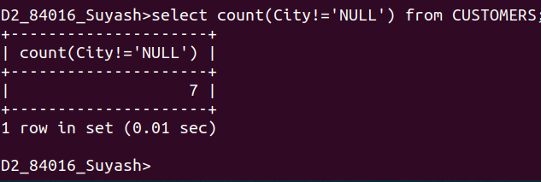
Q3.Write a query that selects each customer’s smallest order.
Ans.
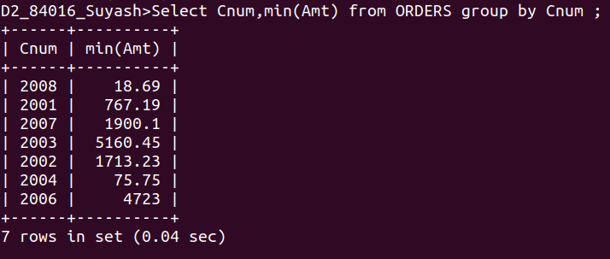

Q4.Write a query that selects the first customer,
in alphabetical order, whose name begins with G.
Ans.

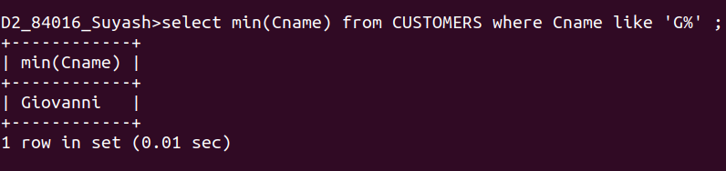

Q5.Write a query that selects the highest rating in each city.
Ans.
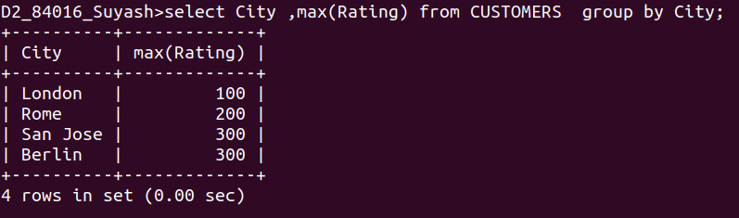
Q6.Write a query that counts the number of salespeople registering orders for each day. (If a salesperson has more than one order on a givenday,he or she should be counted only once.).
ans.
